Data Analyst Project – Sales Management

PORTFOLIO:-

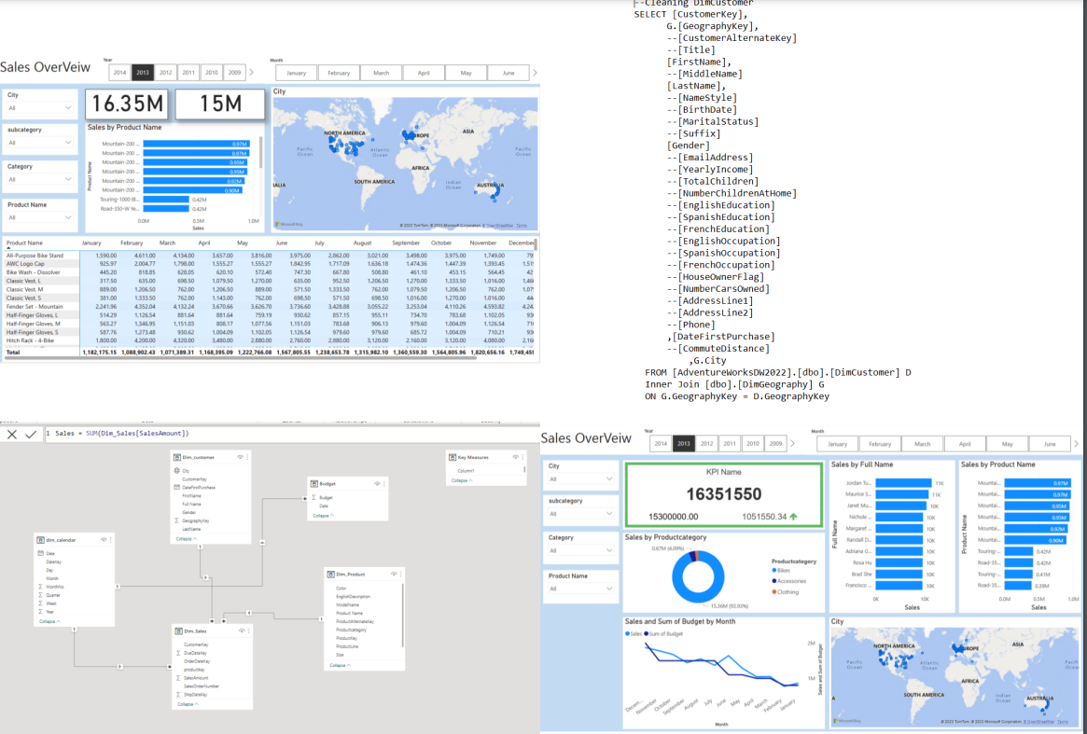

Business Requirement:-

The business request for this data analyst project was an executive sales and product reports. Based on the request that was made from the business we following users stories were defined to fulfil delivery and ensure that acceptance criteria's were maintained throughout the project.

|  |  |
| --- | --- |
| I want (Request/demanded) | Acceptance Criteria |
| To get a dashboard overview of internet sales | A power Bi dashboard which updates data once a day. |
| A detailed overview of Internet sales per customer | A power Bi dashboard which allows me to filter data for each customer |
| A detailed overview of Internet sales per Product | A power Bi dashboard which allows me to filter data for each Product. |

Data Cleaning & Transformation (SQL):-

To create the necessary data model for doing analysis and fulfilling the business needs defined in the user stories the following tables were extracted using sql.

One data source (sales budget) were provided in excel format and were connected in the data model in a later step of the process.

Below are the sql statements for cleaning and transforming necessary data.

DimCustomer:-

--Cleaning DimCustomer

SELECT [CustomerKey],

G.[GeographyKey],

--[CustomerAlternateKey]

--[Title]

[FirstName],

--[MiddleName]

[LastName],

--[NameStyle]

--[BirthDate]

--[MaritalStatus]

--[Suffix]

[Gender]

--[EmailAddress]

--[YearlyIncome]

--[TotalChildren]

--[NumberChildrenAtHome]

--[EnglishEducation]

--[SpanishEducation]

--[FrenchEducation]

--[EnglishOccupation]

--[SpanishOccupation]

--[FrenchOccupation]

--[HouseOwnerFlag]

--[NumberCarsOwned]

--[AddressLine1]

--[AddressLine2]

--[Phone]

,[DateFirstPurchase]

--[CommuteDistance]

,G.City

FROM [AdventureWorksDW2022].[dbo].[DimCustomer] D

Inner Join [dbo].[DimGeography] G

ON G.GeographyKey = D.GeographyKey

DimProduct:-

USE AdventureWorksDW2022

SELECT ProductKey,ProductAlternateKey,EnglishProductName AS [Product Name],PS.EnglishProductSubcategoryName AS subcategory, PC.EnglishProductCategoryName As Productcategory

,Color,Size,ProductLine,ModelName,EnglishDescription,ISNULL (Status,'NA') As STATUS

From DimProduct DP

LEFT JOIN [dbo].[DimProductSubcategory] PS ON PS.ProductSubcategoryKey = DP.ProductSubcategoryKey

LEFT JOIN [dbo].[DimProductCategory] PC ON PC.ProductCategoryKey = PS.ProductCategoryKey

Order By ProductKey ASC

Dat Model:-

Below is screenshot of the data model after cleansed and prepared tables were read into Powerbi.

This data model also shows how Fact_Budget has been connected_Internetsales and another necessary DIM tables.

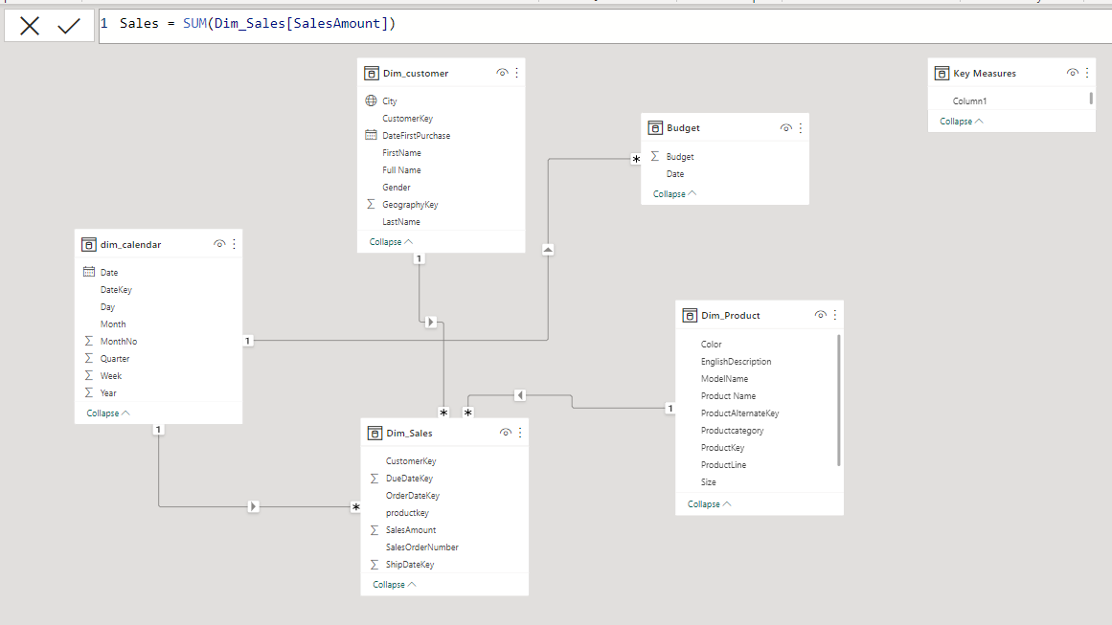

Sales Management Dashboard:-

The finished sales management dashboard with one page with works as a dashboard and overview, with 1 other page focused on combing tables for necessary details and visualization to show sales over time, per products.

